**Advance Excel Assignment 5**

1. How many types of conditions are available in conditional formatting on Excel?

Ans. Conditional formatting can help make patterns and trends in your data more apparent. To use it, user create rules that determine the format of cells based on their values. Users can apply conditional formatting to a range of cells (either a selection or a named range), an Excel table, and in Excel for Windows, even a PivotTable report.

* There are 5 types of conditional formatting visualizations available:
* Background Color Shading (of cells)
* Foreground Color Shading (of fonts)
* Data Bars
* Icons (which have 4 different image types)
* Values
* There are many types of conditions available in conditional formatting :
* Highlight Cells Rules : Greater Than, Less Than, Between, Equal To, Text that Contains, A Date Occurring, Duplicate Values.

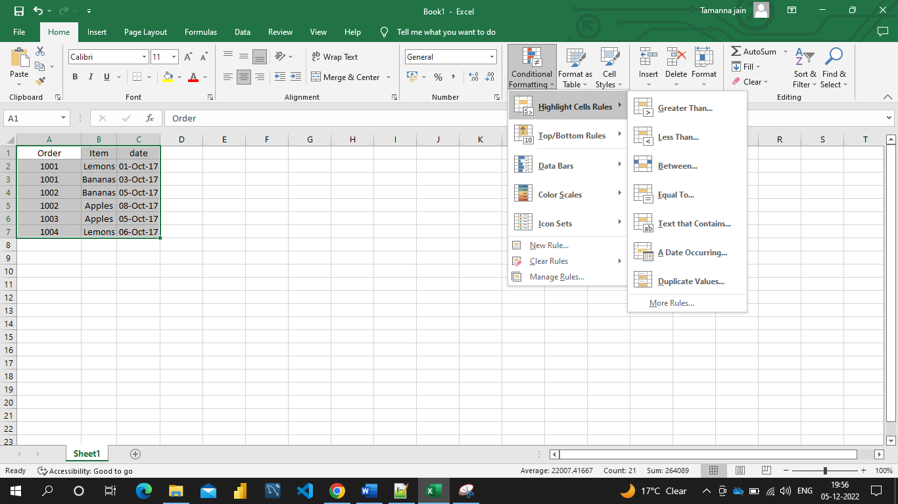

* Top/Bottom Rules : Top 10 items, Top 10 %, Bottom 10 items, Bottom 10 %, Above Average, Below Average.

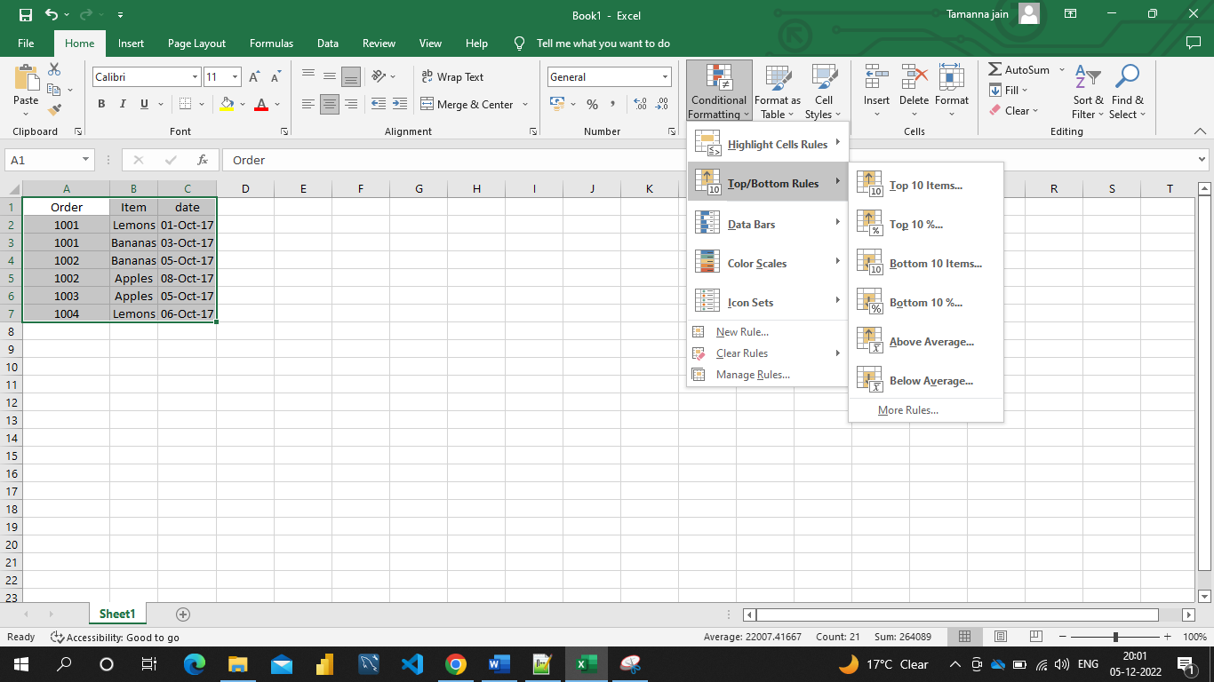

* Data Bars : Gradient Fill, Solid Fill.

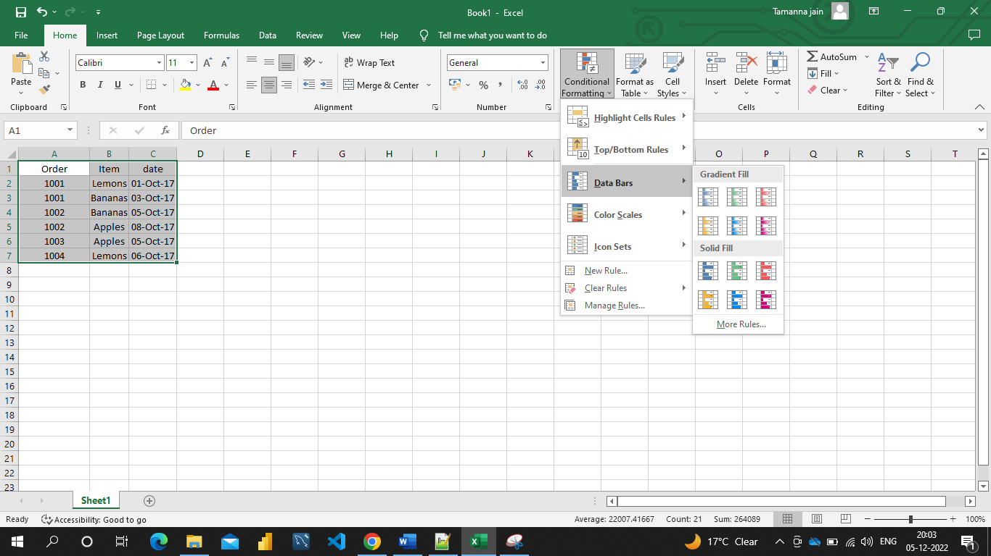

* Color Scales :

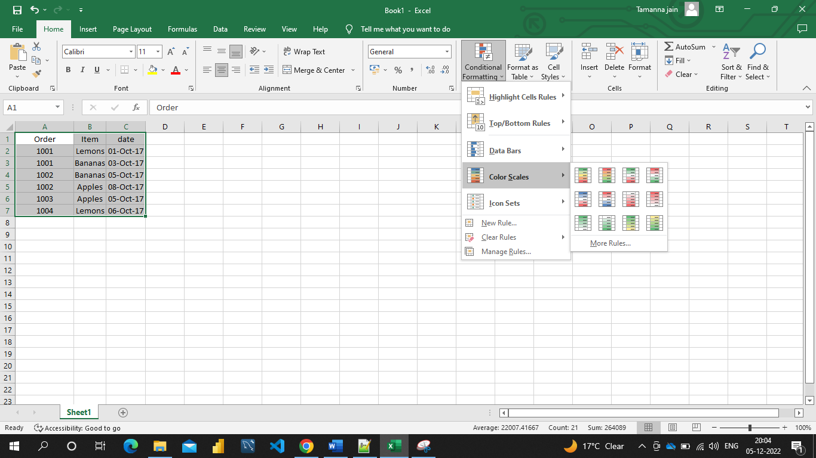

* Icon Sets : Directional, Shapes, Indicators, Ratings.

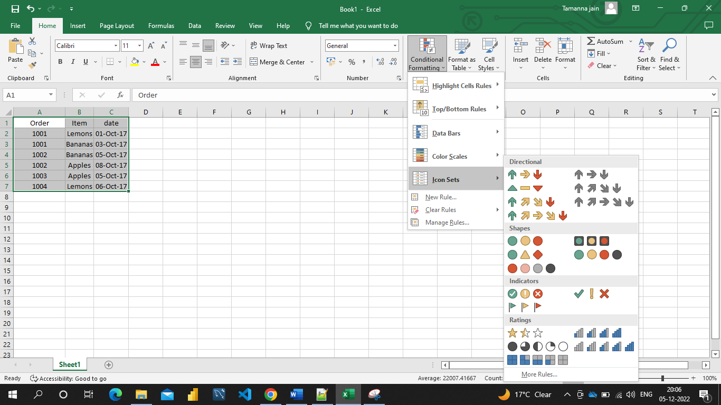

And many more.

1. How to insert border in Excel with Format Cells dialog?

Ans. The Format Cells dialog is the most effective method of adding borders in Excel. It gives users easy access to all the settings including the line color and thickness as well as a nice diagram preview.

To insert a border via the Format Cells dialog, this is what we need to do:

* + Select one or more cells to which you'd like to add borders.
  + Open the Format Cells dialog box by doing one of the following:
    - Click the down arrow next to the Borders button, and then click More Borders at the bottom of the drop-down list.
    - Right click the selected cells and choose Format Cells*…* from the context menu.
    - Press ctrl+1 shortcut.

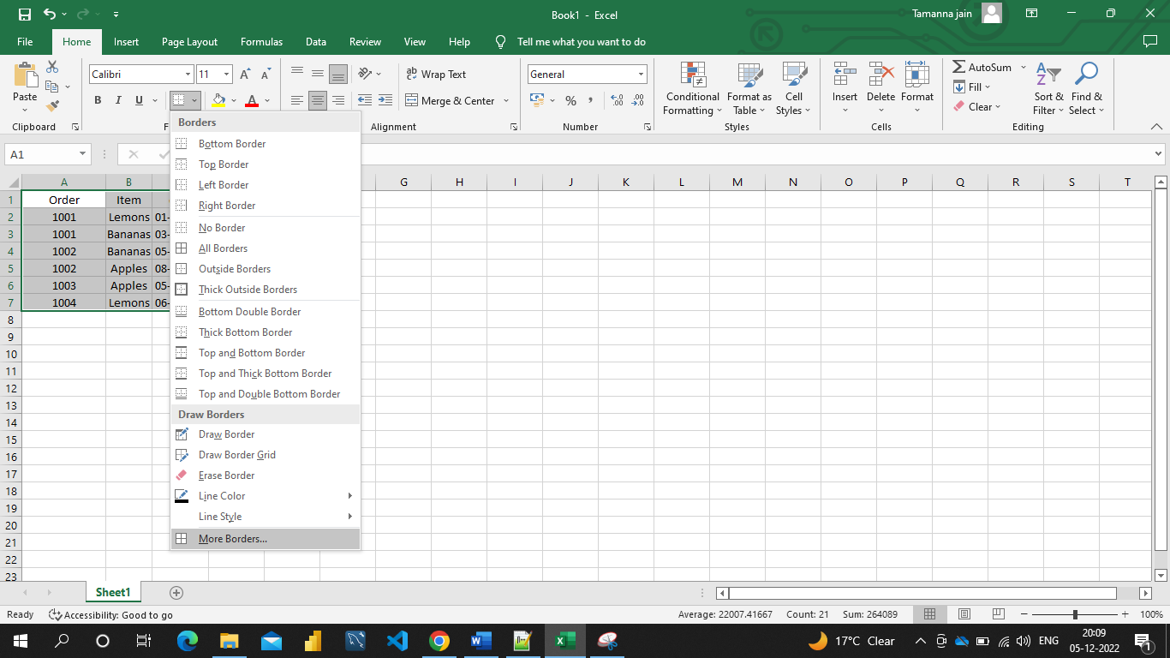

* In the Format Cells dialog box, switch to the Border tab and choose the line style and color first. And then, either use Presets to add the outside or inside borders or construct the desired border by selecting individual elements such as border top, bottom, right or left. The preview diagram will reflect the changes immediately.
* When done, click OK.

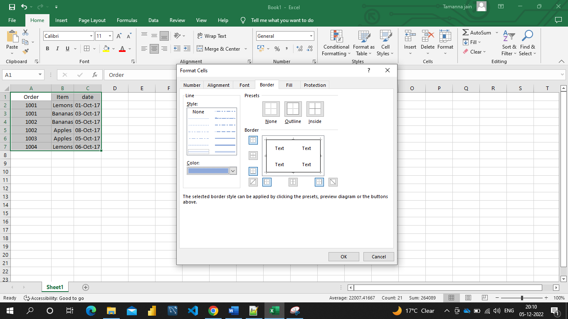

1. How to Format Numbers as Currency in Excel?

Ans. In the Home toolbar is the Number Format drop down menu. It displays the current number formatting for the selected cell and allows you to change the format quickly.

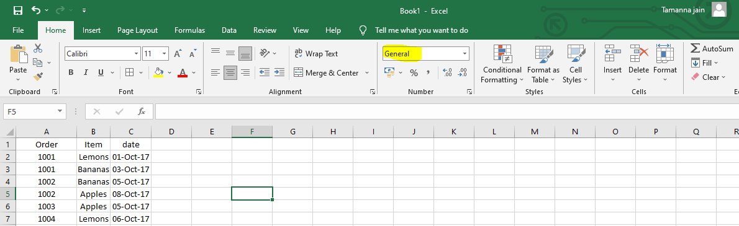

Click on the arrow to the right. This opens the drop down menu.

Select either Currency or Accounting. Either one will format the cell for money.

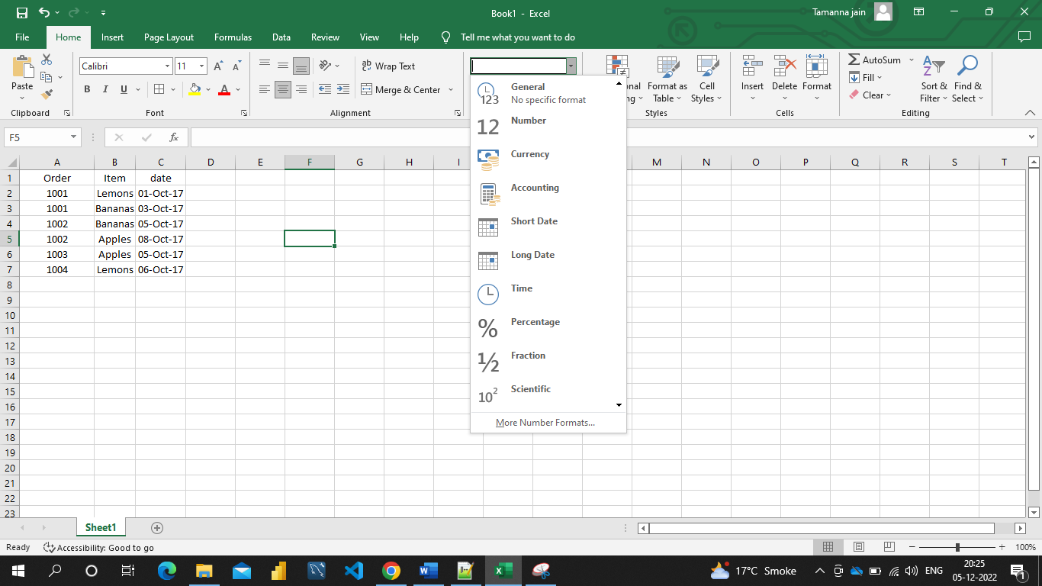

1. What are the steps to format numbers in Excel with the Percent style?

Ans. To quickly apply percentage formatting to selected cells, click Percent Style % in the Number group on the Home tab, or press Ctrl+Shift+%. If you want more control over the format, or you want to change other aspects of formatting for your selection, you can follow these steps :

On the Home tab, in the Number group, click the icon next to Number to display the Format Cells dialog box.

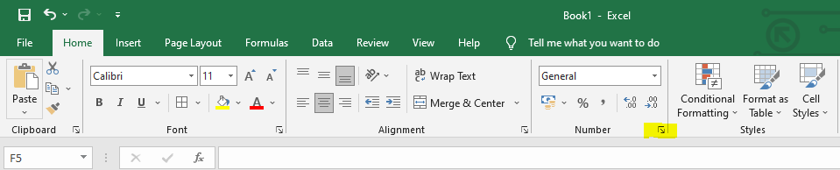

In the Format Cells dialog box, in the Category list, click Percentage.

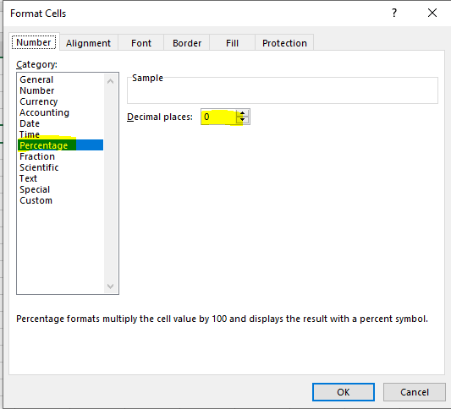

In the Decimal places box, enter the number of decimal places that you want to display. For example, if you want to see 10% instead of 10.00%, enter 0 in the Decimal places box.

1. What is a shortcut to merge two or more cells in excel?

Ans. To merge two or more cells, highlight them and then press the following keys at the same time: ALT H+M+M. Merge and center cells: If you would like to merge cells and center your text at the same time, you can highlight the cells and press these keys: ALT H+M+C.

1. How do you use text commands in Excel?

Ans. The Excel TEXT Function[[1]](https://corporatefinanceinstitute.com/resources/excel/excel-text-function/#citation-text-function-20d5ac4d-7b94-49fd-bb38-93d29371225c) is used to convert numbers to text within a spreadsheet. Essentially, the function will convert a numeric value into a text string. TEXT is available in all versions of Excel.

Formula : =Text(Value, format_text)

Where: **Value** is the numerical value that we need to convert to text

**Format_text** is the format we want to apply

We use the TEXT function in the following circumstances:

* When we want to display dates in a specified format
* When we wish to display numbers in a specified format or in a more legible way
* When we wish to combine numbers with text or characters